Experiment 9: Design and Implement a Synchronous BCD Counter with J-K flip-flops

Peter Dranishnikov  
U0000005258  
EEL3702C Section 04  
Professor: Dr. Balasubramaniyan Chandrasekaran



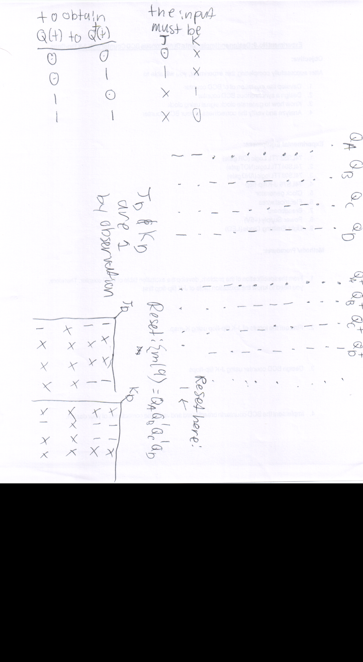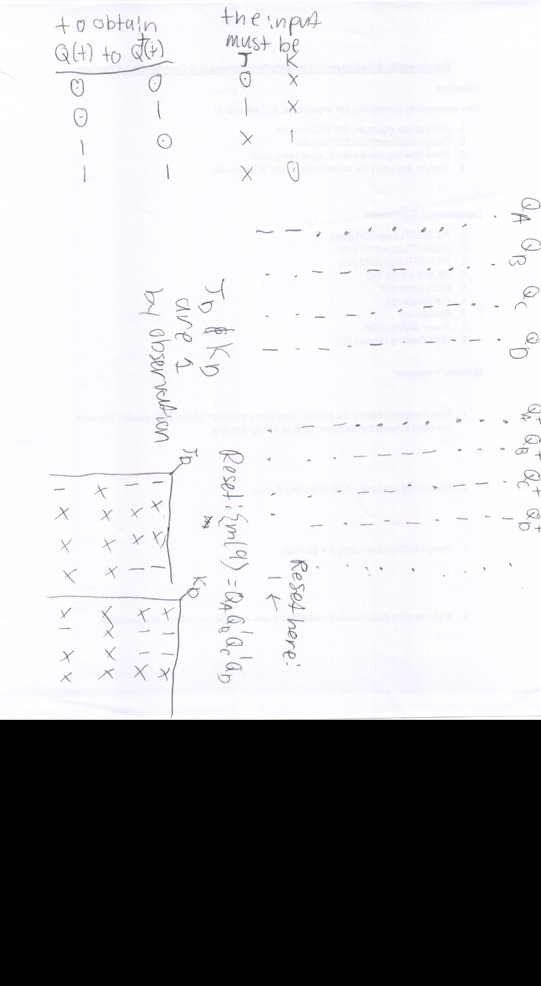

Transition trigger: Clock is ‘0’

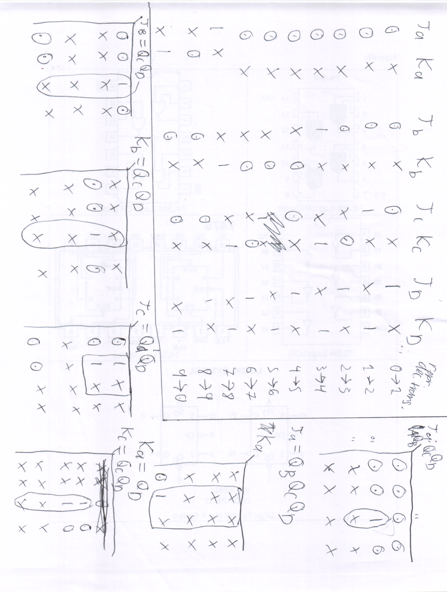

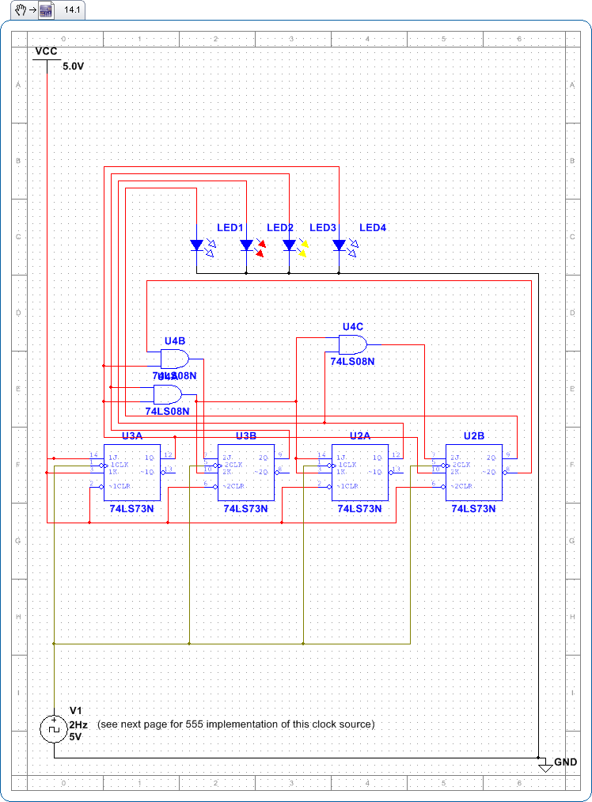

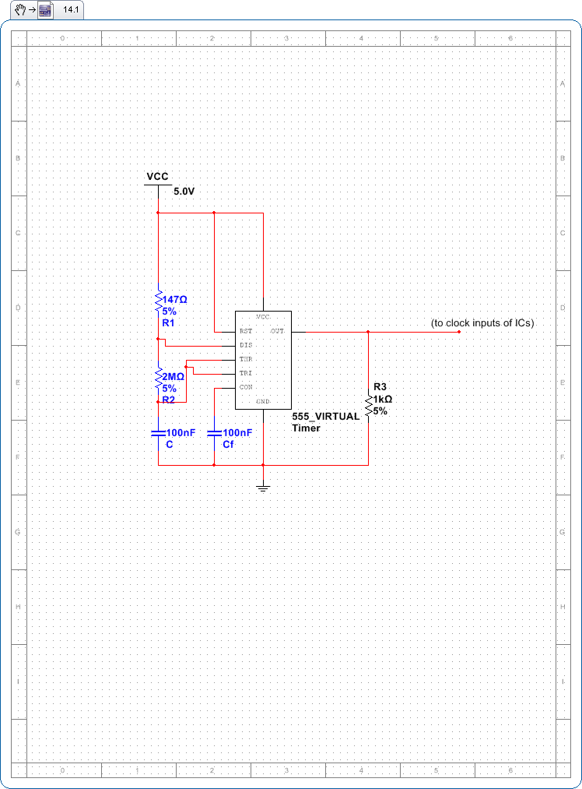

# Results and Discussion:

Initially, the SN74LS76 IC was planned for use. However, supply constraints required use of the SN74LS73 IC as the J-K flip-flop. Additionally, the 555 timer used for the clock signal generator was initially tuned (schematic not shown) to 500 hz. However, it was nearly impossible to determine the correct sequence of the BCD output due to the LED switching quickly from the fast flip-flops and gate logic per clock cycle. Multiplying the capacitance by 10 and increasing the resistance between the discharge and the threshold/trigger pins to 2 MΩ.

# Conclusion:

It is possible to design and construct a sequential circuit representing a finite state machine by determining the excitation table of the flip-flop(s) in use, applying that table to the full transition state table (modeled after a Moore state machine diagram) using previously-learned combinational design methods (K-maps, Boolean simplification) to determine the combinational logic and circuit between the flip-flop’s I/O.

# References

Texas Instruments. (1988, March). *SN74LS73.* Retrieved from http://www.ti.com/lit/ds/symlink/sn74ls73a.pdf

Texas Instruments. (2015, January). *LM555.* Retrieved from http://www.ti.com/lit/ds/symlink/lm555.pdf



